**MongoDB Assignment 2**

**By Afreen Sultana A**

**MongoDB Projection Operators**

MongoDB also provides certain **projection operators** that we can use to modify how fields are returned. These operators allow for more advanced selection and reshaping of data.

**$slice Operator**

db.employee.insertOne({name:'Afreen', skills:["Python", "C", "Java", "SQL","MongoDB"]})

db.employee.find({name:"Afreen"},{skills:{$slice:[1,3]}})

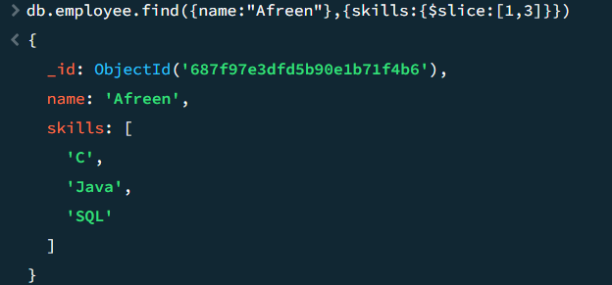

**$elemMatch Operator**

db.Employees.find({skills: { $elemMatch: { name: "MongoDB" }}})

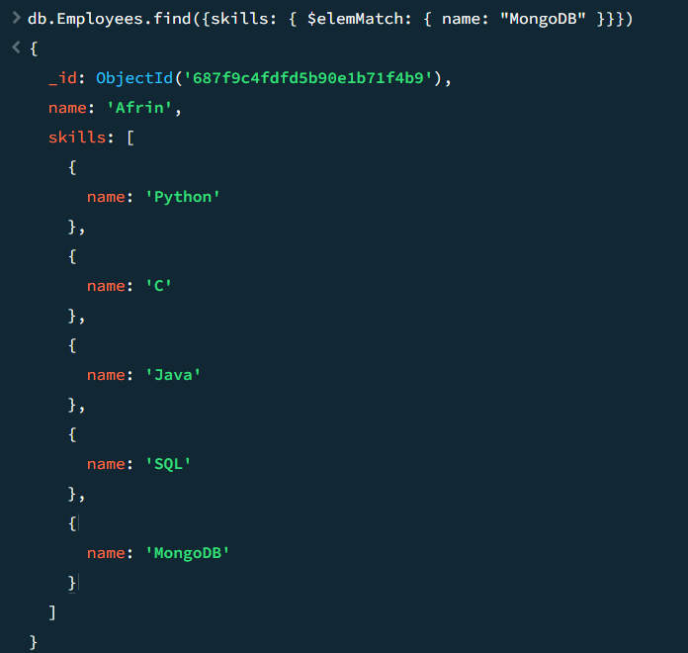

[**Atomicity and Transactions**](https://www.mongodb.com/docs/manual/core/write-operations-atomicity/#atomicity-and-transactions)  
db.games.insertOne({_id:1,score:80})

db.games.updateOne({score:80},{$set:{score:90}})

db.games.update({score:80},{$set:{score:100}})

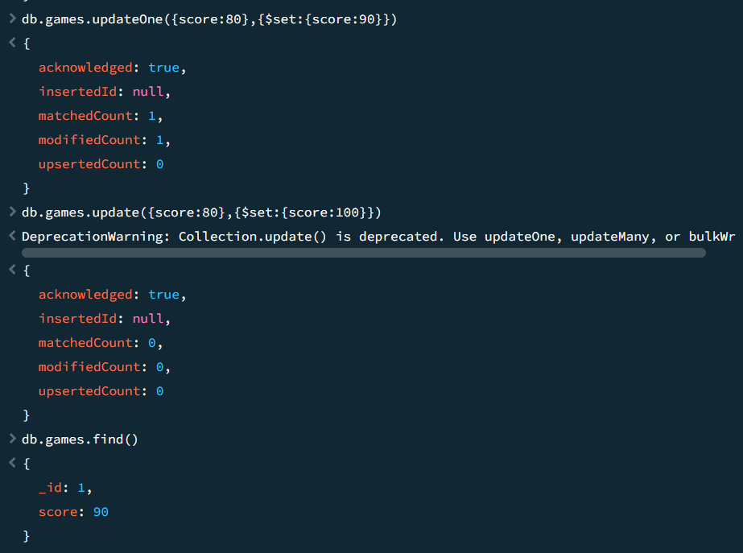

db.games.insertOne({_id:1,score:70})

**MongoServerError:** E11000 duplicate key error collection: GameDB.games index: _id_ dup key:

db.games.deleteMany({status:{$lte:70}})

db.games.deleteMany({})

db.students.updateOne({name:'Afreen'},{$set:{course:'java'}})

db.students.find({name:'Afreen'})

db.students.updateMany({age:{$gt:25}},{$set:{status:'C'}})

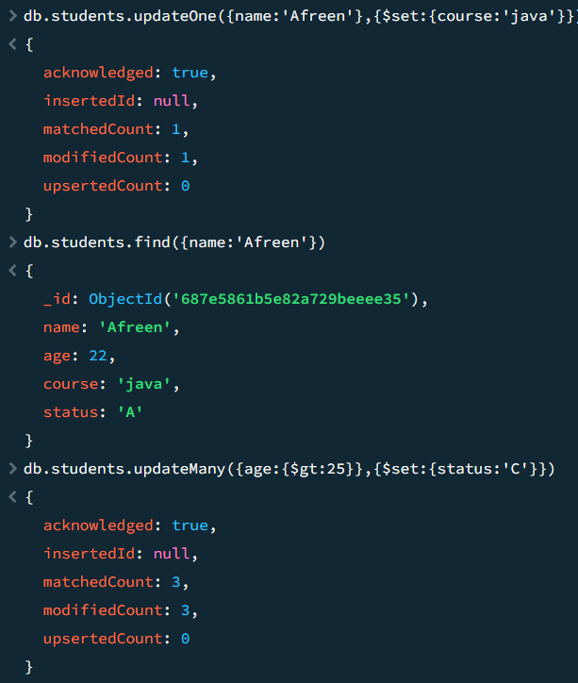

db.students.find({}, {age:25}).pretty()

